JFROG:

Steps to deploy the build to the antifactory tool (JFROG)

1. We are using trail version of Jfrog, so we can deploy the build from main branch only.  
   Jfrog will create a new t2.medium instance on our behalf and create the folders under the same instance
2. Create a jfrog account
3. click on profile and quick repository creation  
   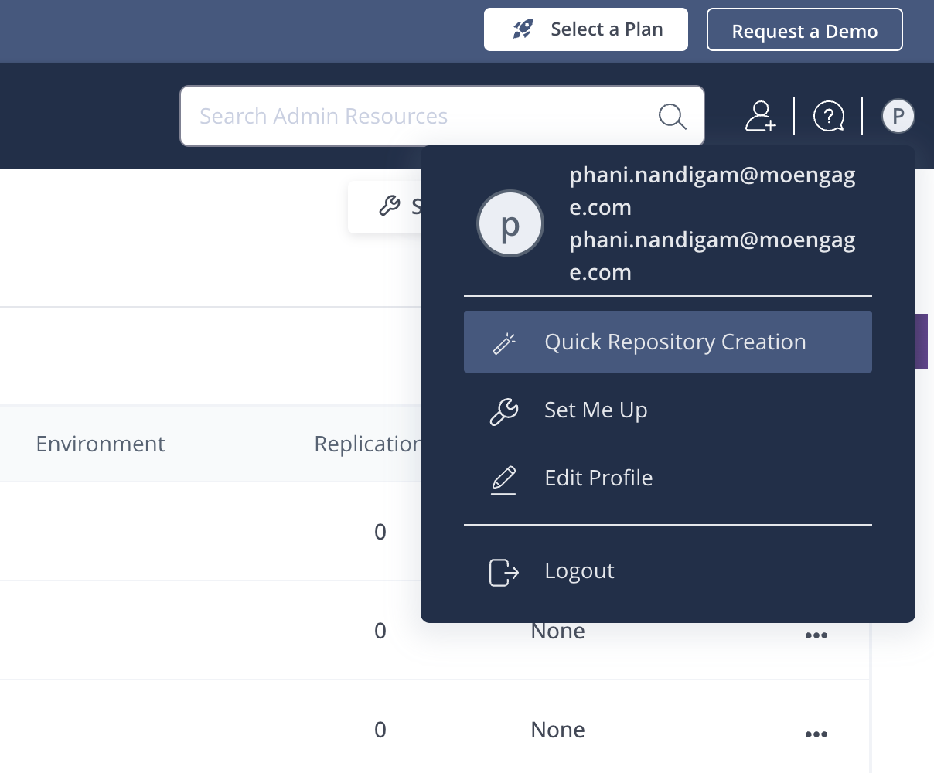
4. Select the respective build tool. In our case it’s maven  
   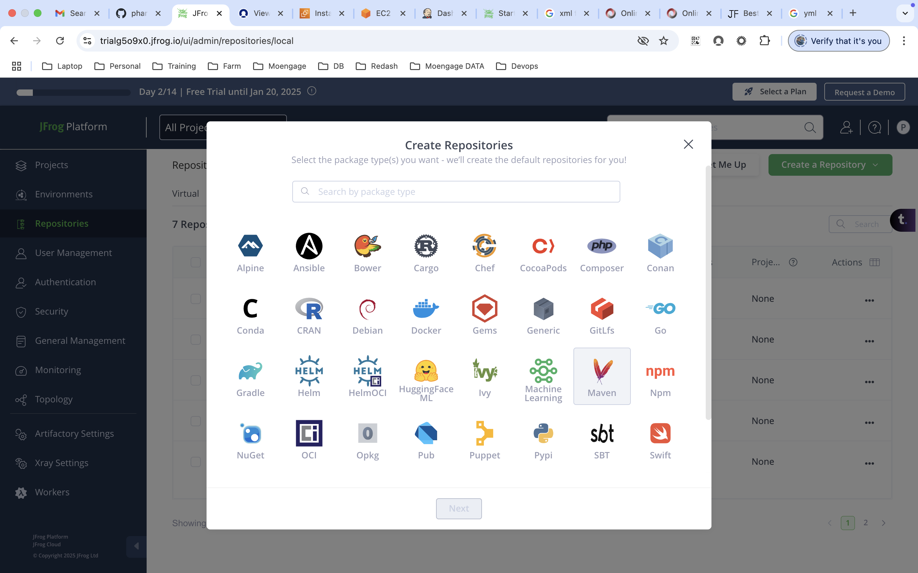
5. Enter the prefix name. It can be anything.   
   Based on the name which we provide, it will create folders like snapshot and libraries  
   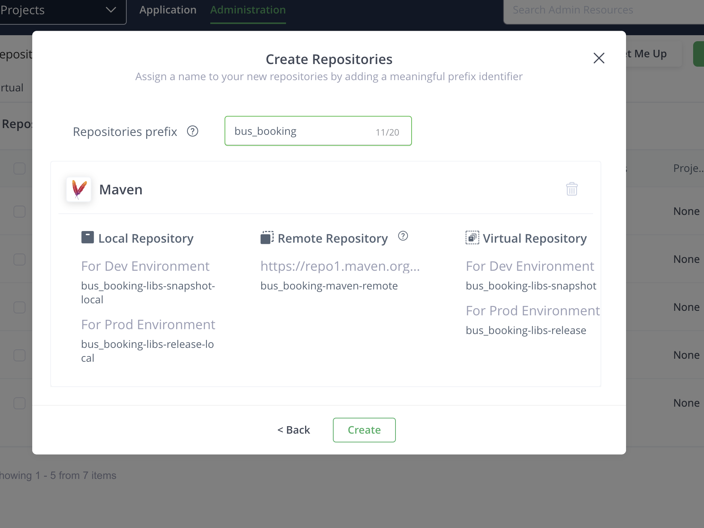  
   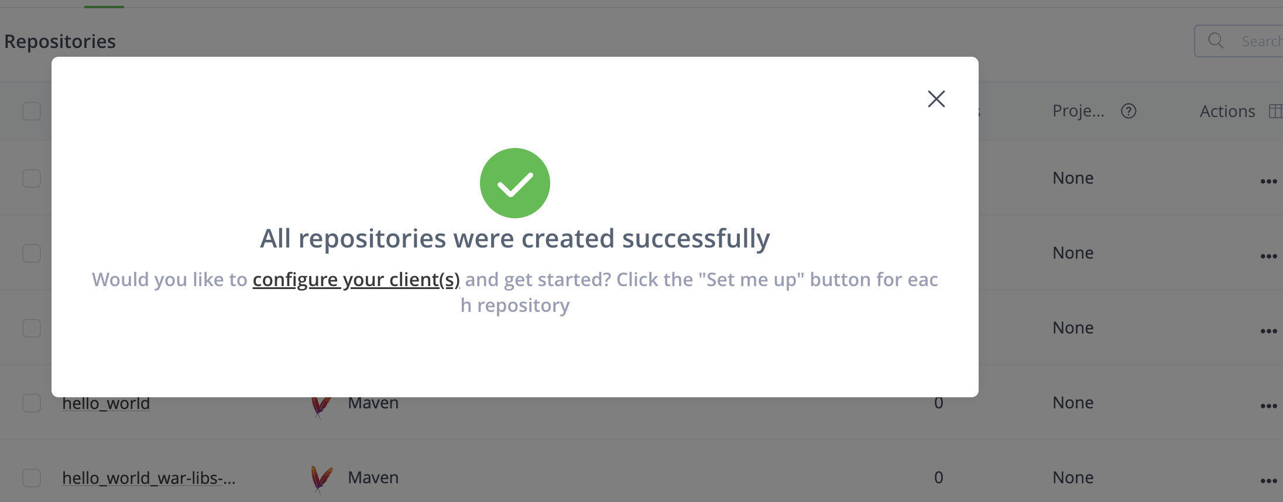
6. click on configure your clients  
   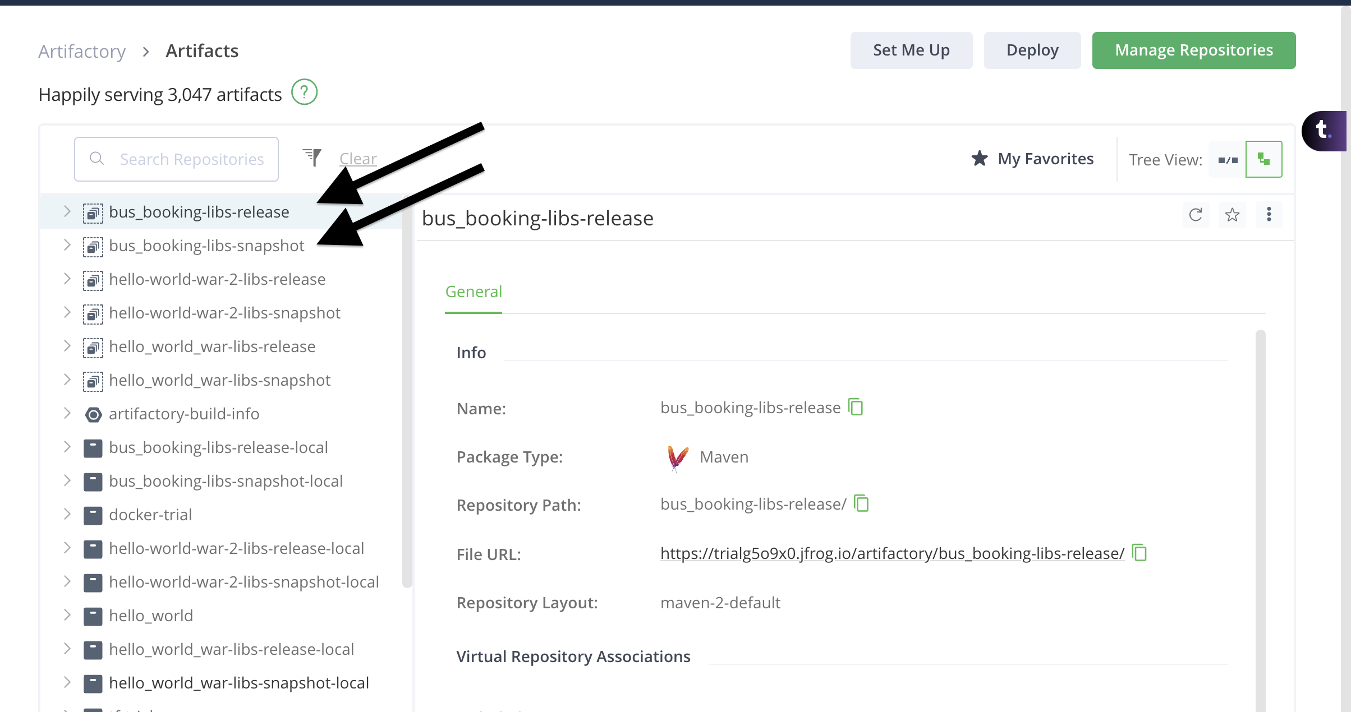
7. Select the release folder and click on set me up on the top right side
8. This will provide the token and the XML snippet, which has to be used under pom.xml  
   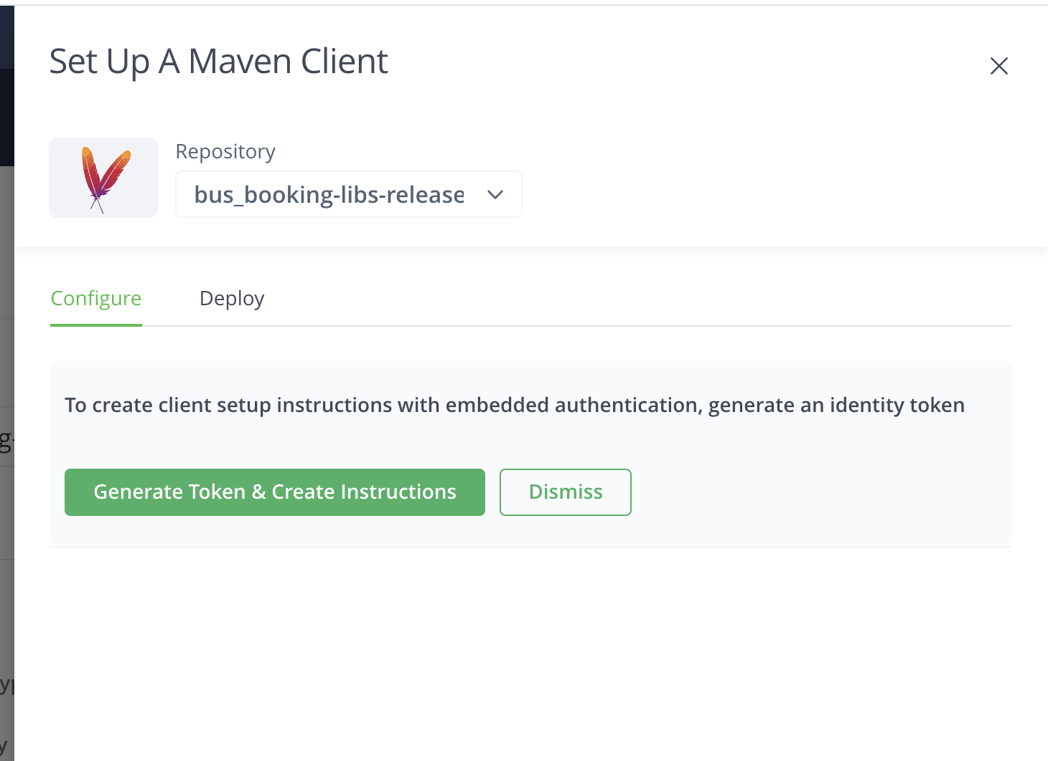  
   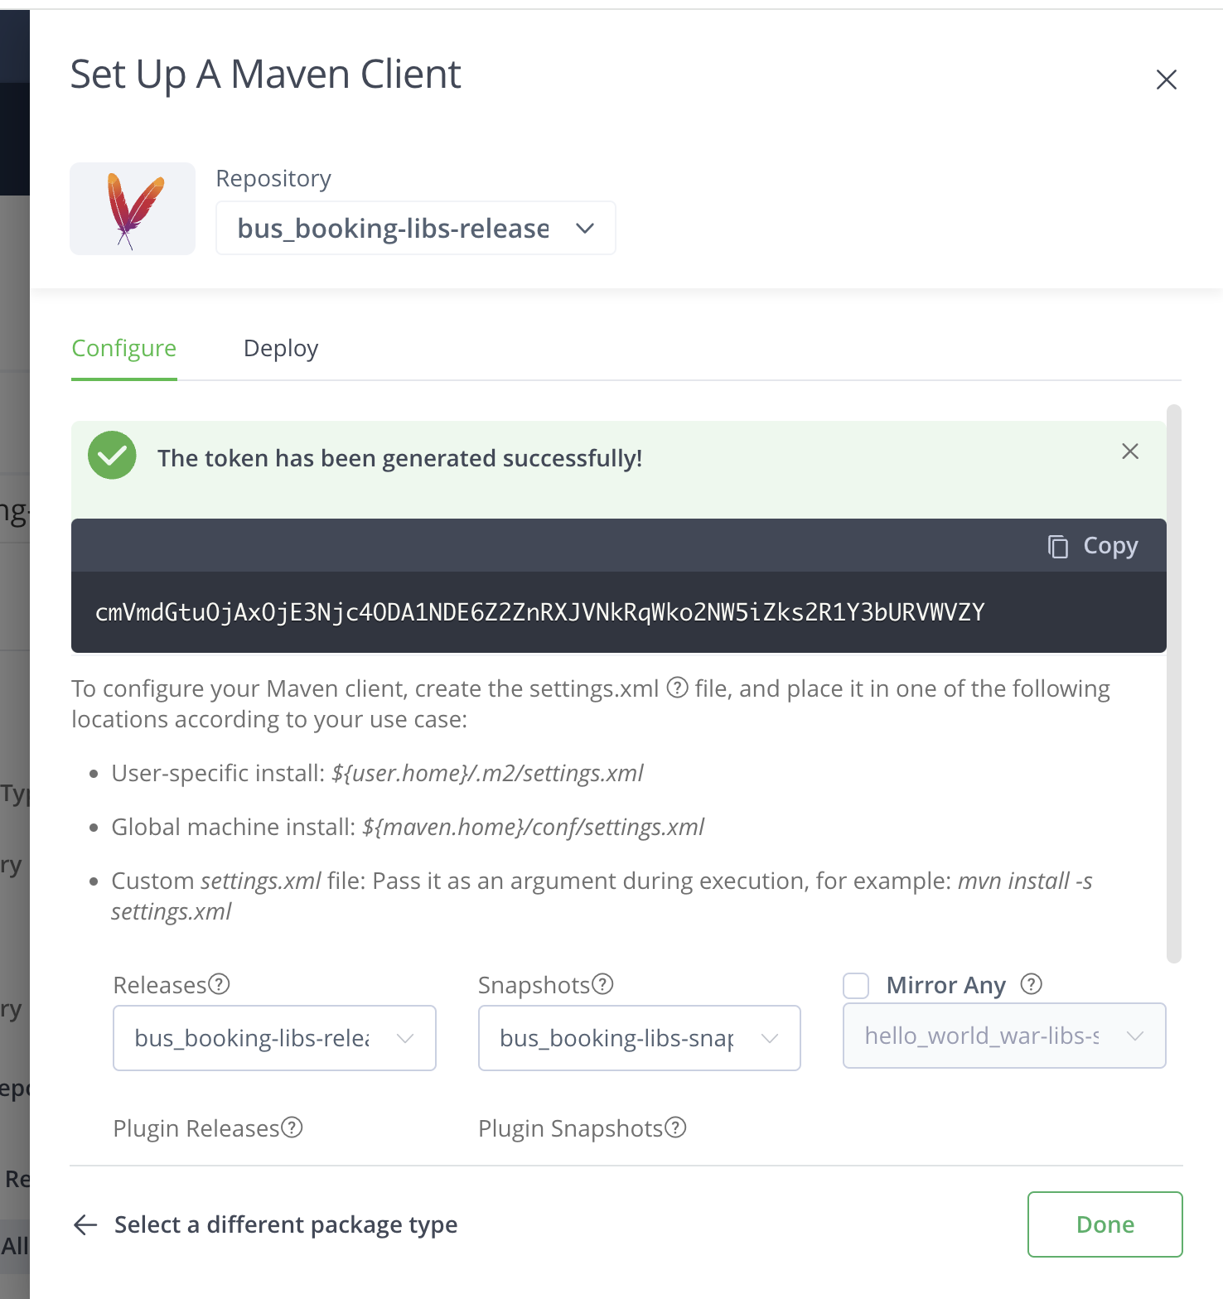  
     
   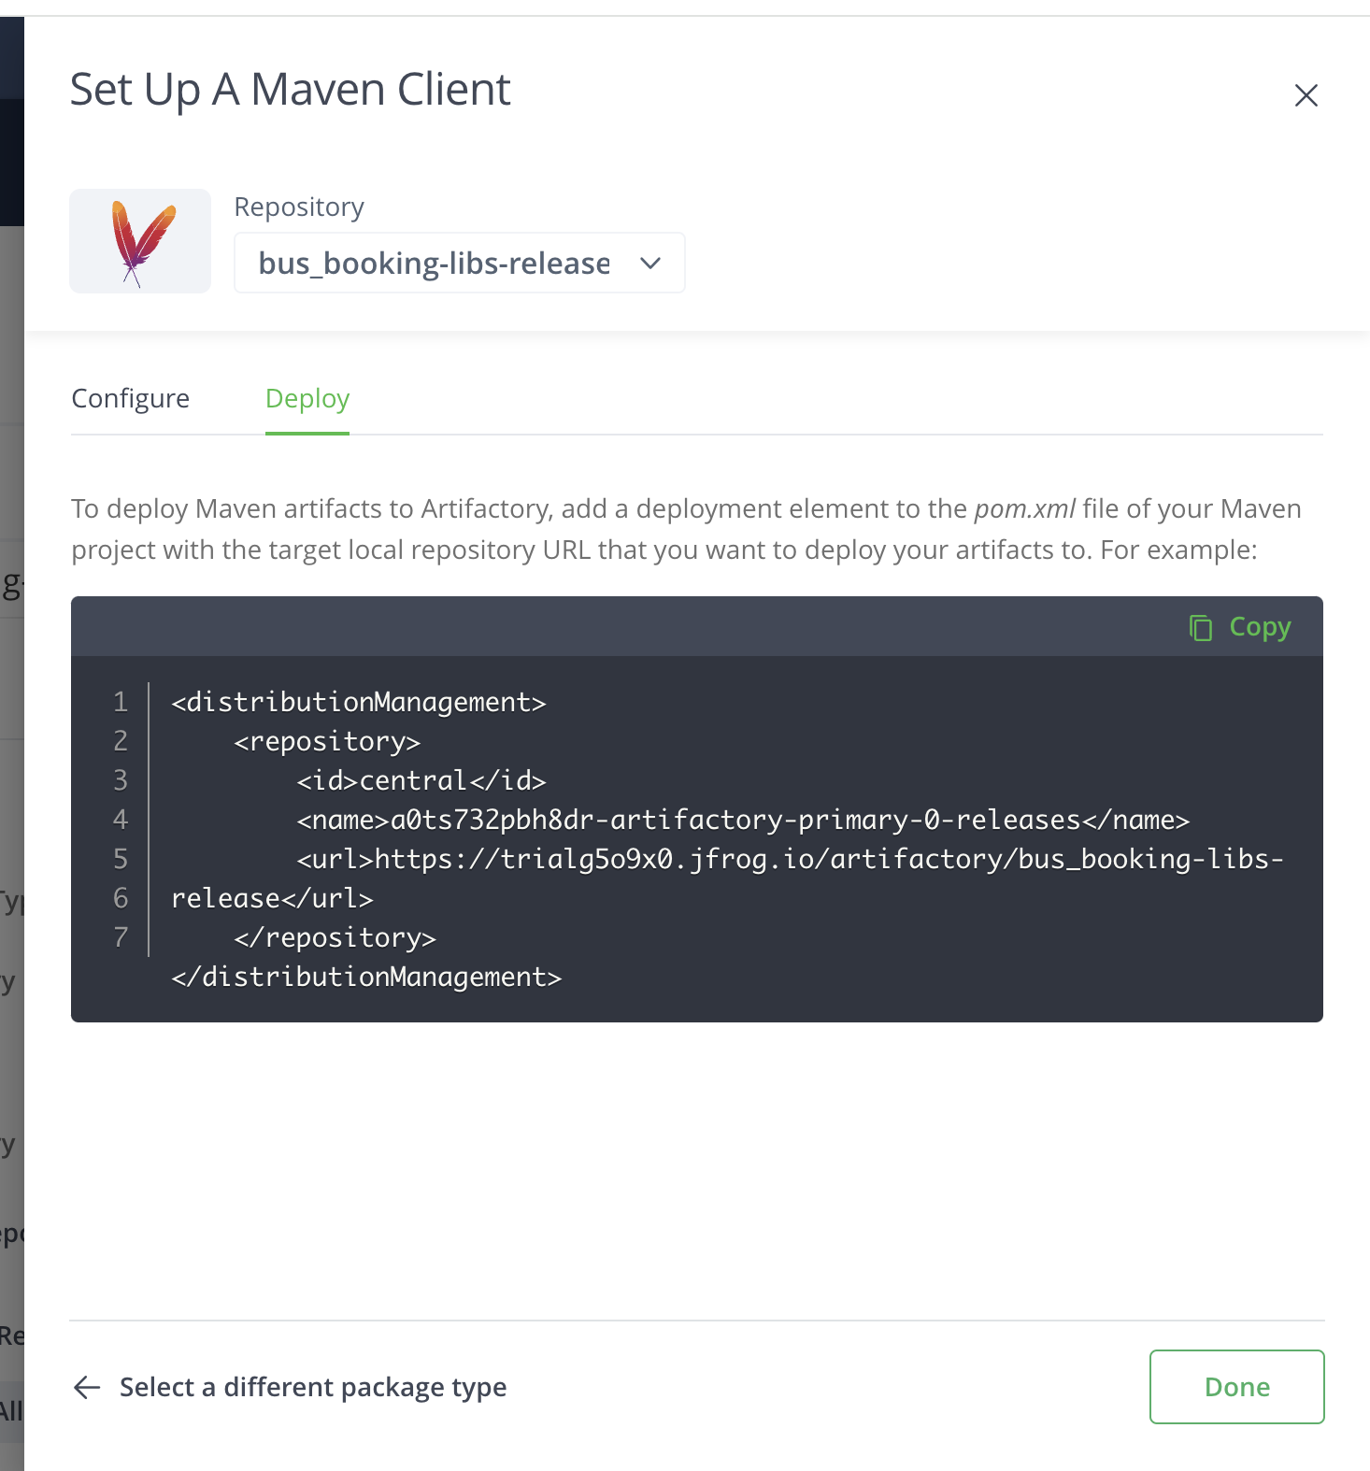
9. Copy and paste the XML snippet under pom.xml under the specific project (bus booking)
10. Paste the snippet after the packing tag  
    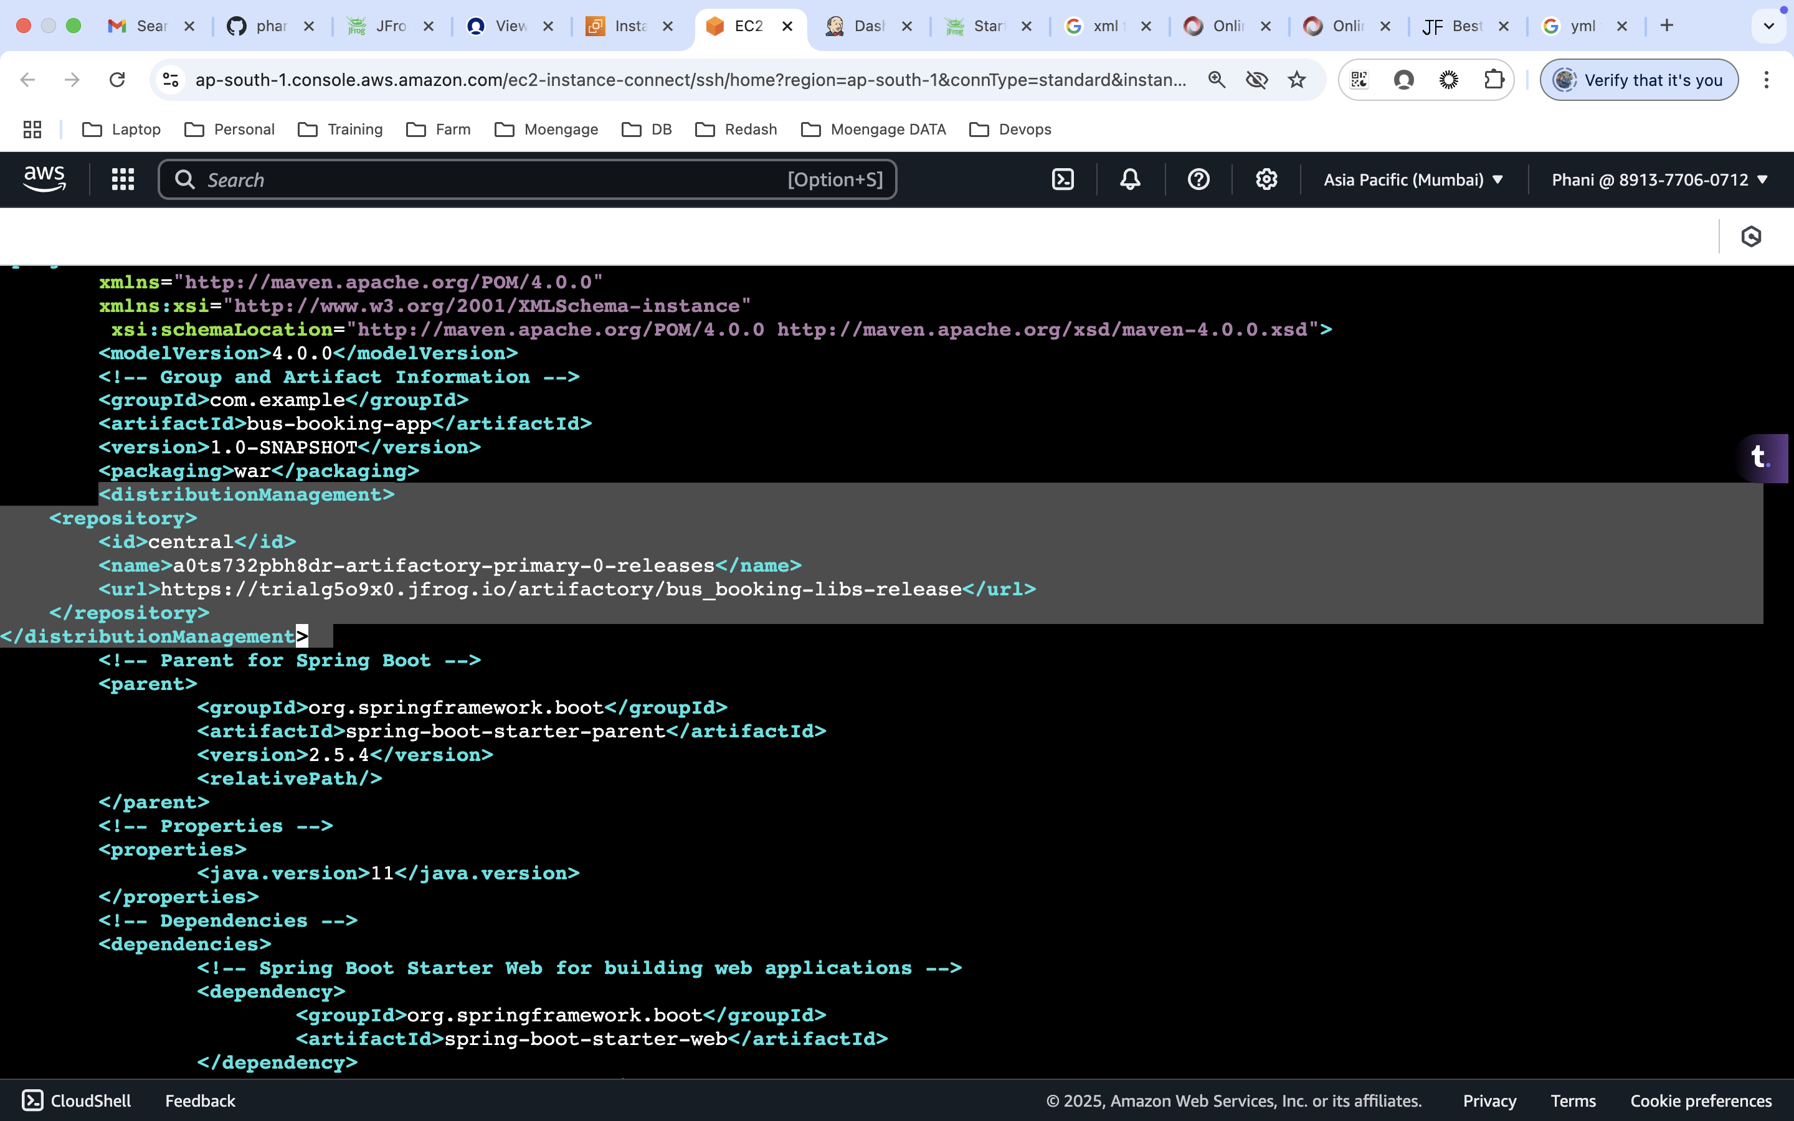
11. We are trying to deploy the build manually from the terminal and hence we are updating the local copy. We will be using git actions as well once we are done with this. In that case we need to update the pom.xml in remote repo
12. The pom.xml will deploy the build to the artifactory tool based on the config which we have updated.
13. Now we need to provide the authentication to the artifactory tool
14. This will be done via settings.xml under local maven repo (.m2)
15. If the settings.xml is not present, we need to create one and add the below content.

|  |
| --- |
| <settings>  <servers>  <server>  <id>central</id> <!-- This ID must match the one in your pom.xml -->  <username>phani.nandigam@moengage.com</username> <!-- Replace with your JFrog Artifactory username -->  <password>cmVmdGtuOjAxOjE3Njc4ODA1NDE6Z2ZnRXJVNkRqWko2NW5iZks2R1Y3bURVWVZY</password> <!-- Use the API key here instead of your password -->  </server>  </servers>  </settings> |

1. We need to modify the id, username and password.
2. We can get the ID value from jfrog, username is the email using which we logged into the jfrog and the password will be token which we have generated.  
   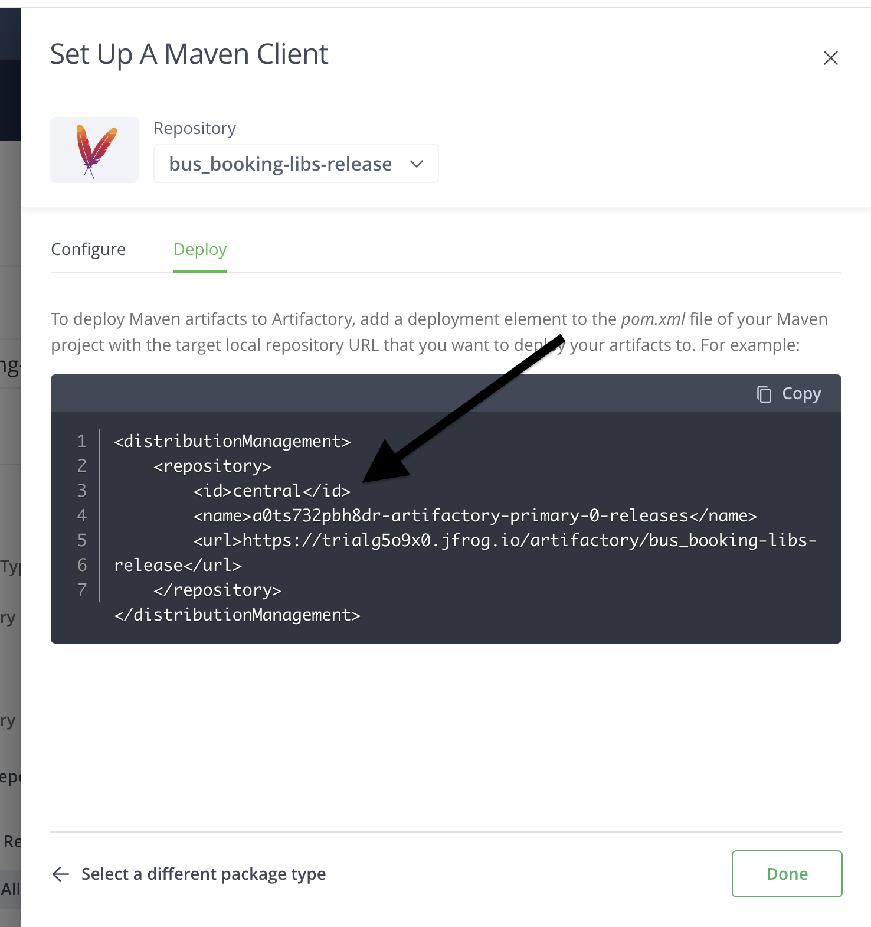  
   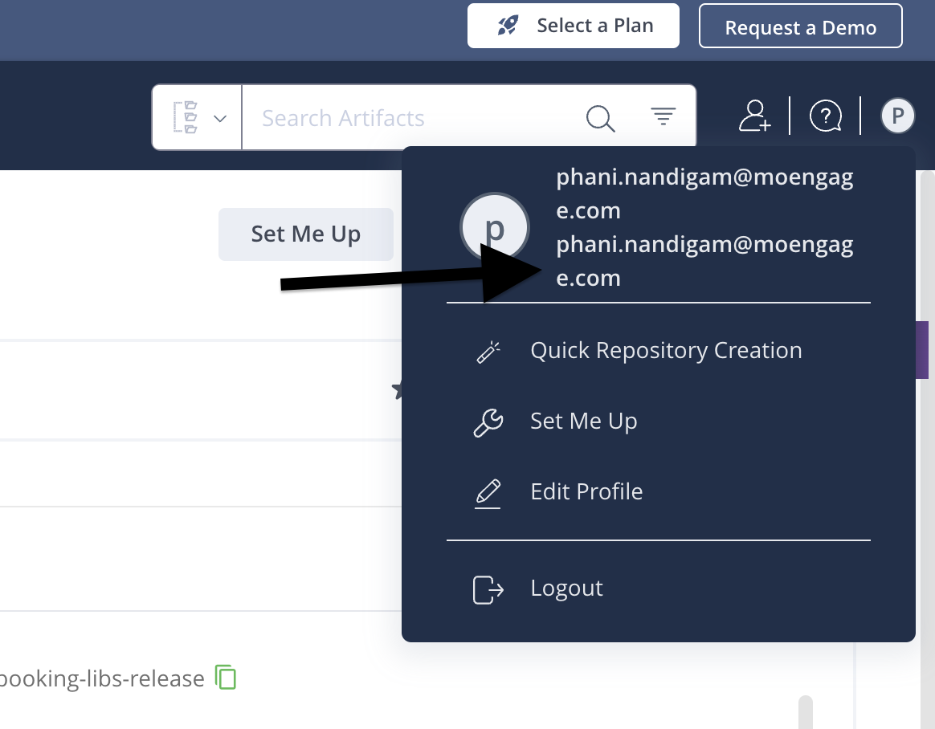  
     
   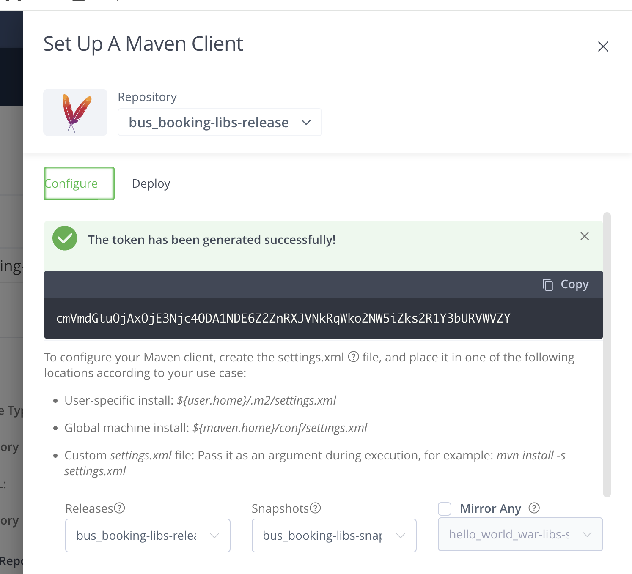
3. Run the mvn clean deploy command  
   make sure the pom.xml has correct indentation, else it will throw the error.  
   Also, if we are trying to deploy this artifact under release folder, we need to follow the naming conventions for it.

Update the below code under pom.xml  
<version>1.0.1</version>  
  
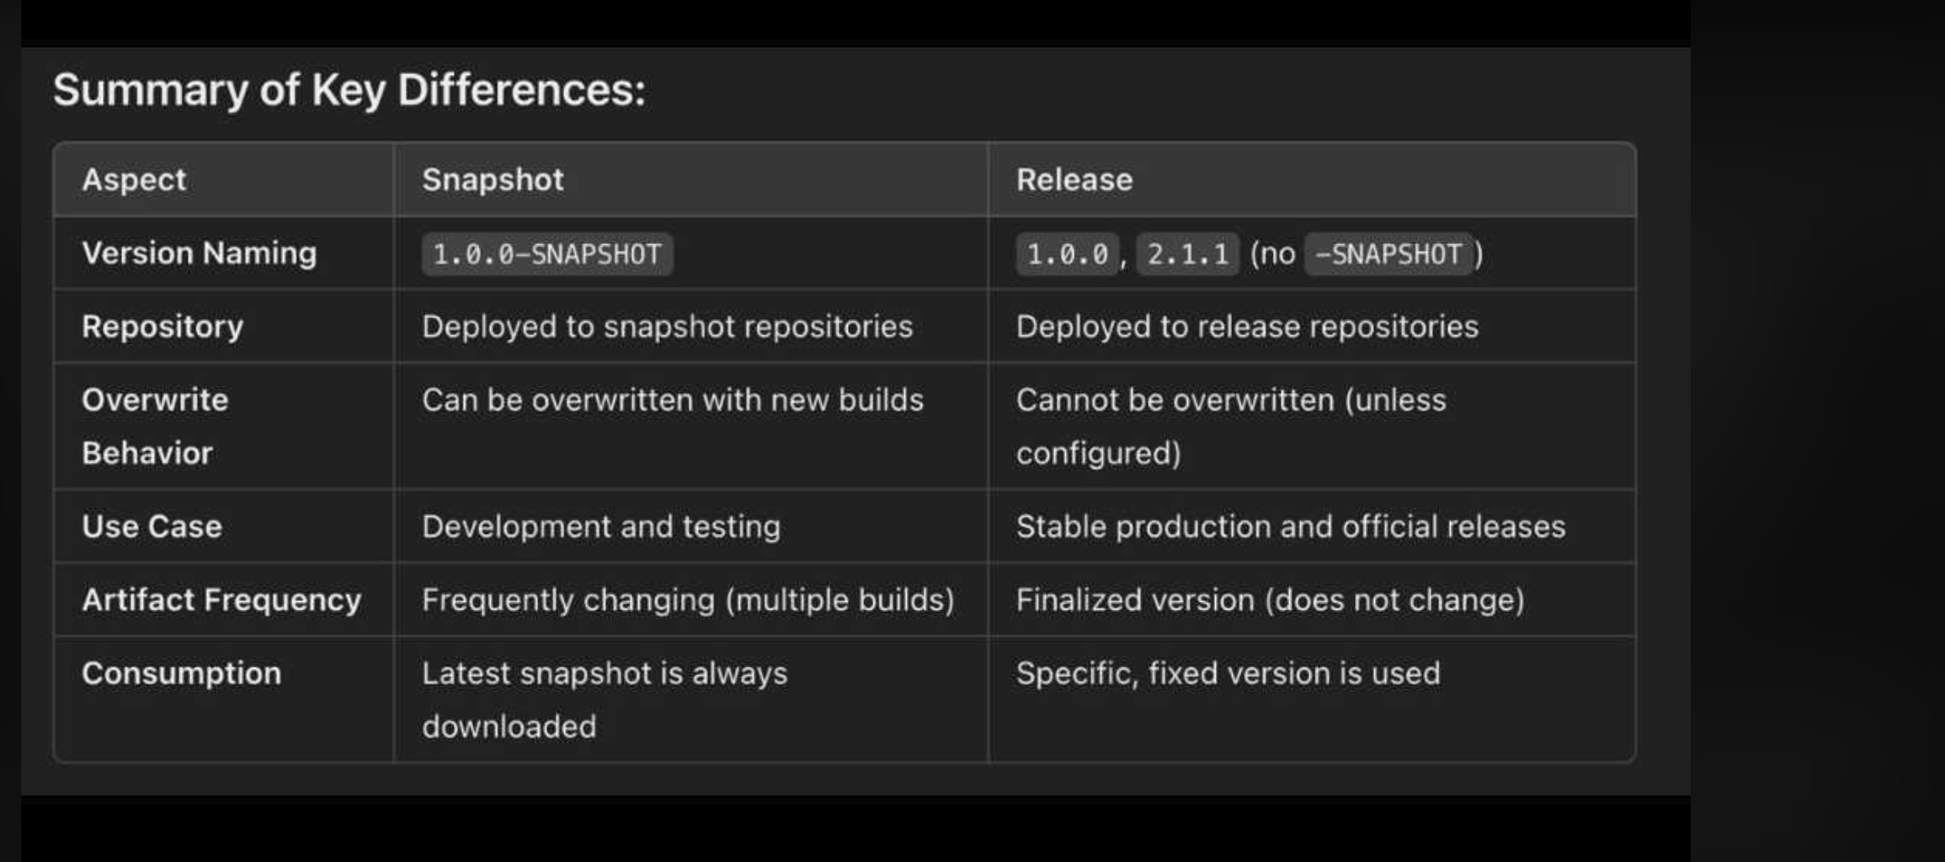  
use online tools to have the proper syntax  
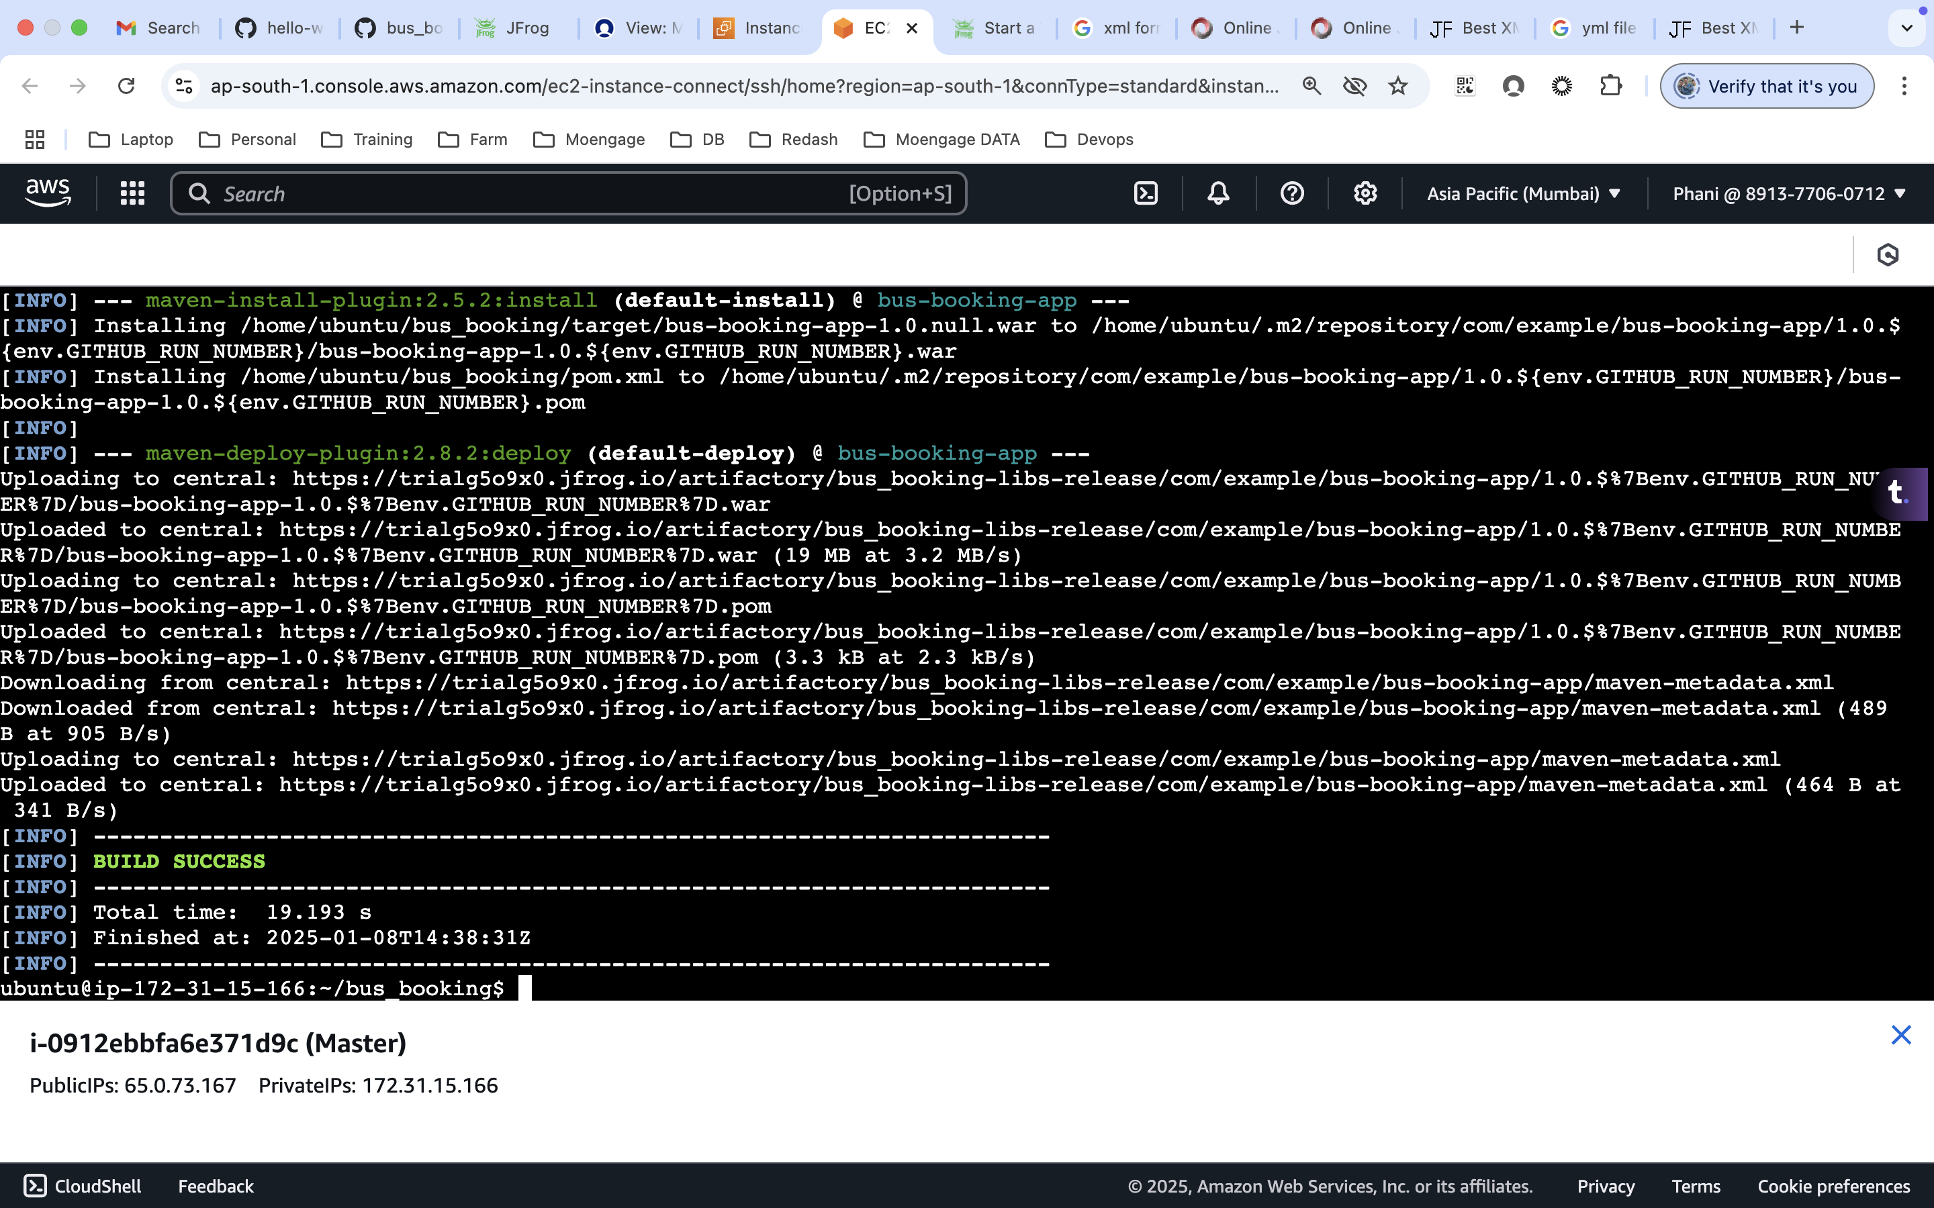

Before  
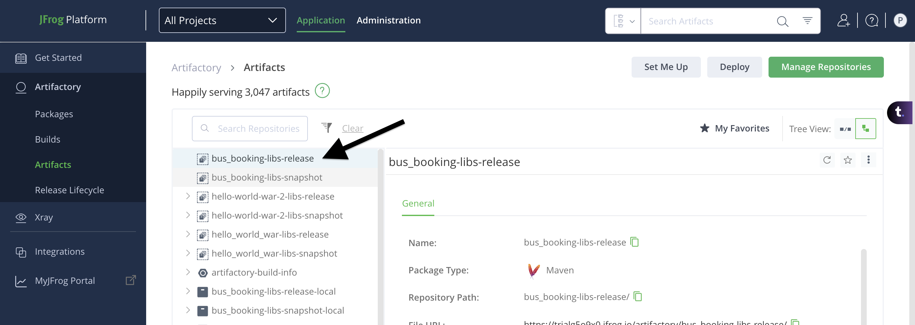  
  
After build success (ignore the 1.0.$7B folder, under pom.xml the variable used was wrong in my case)  
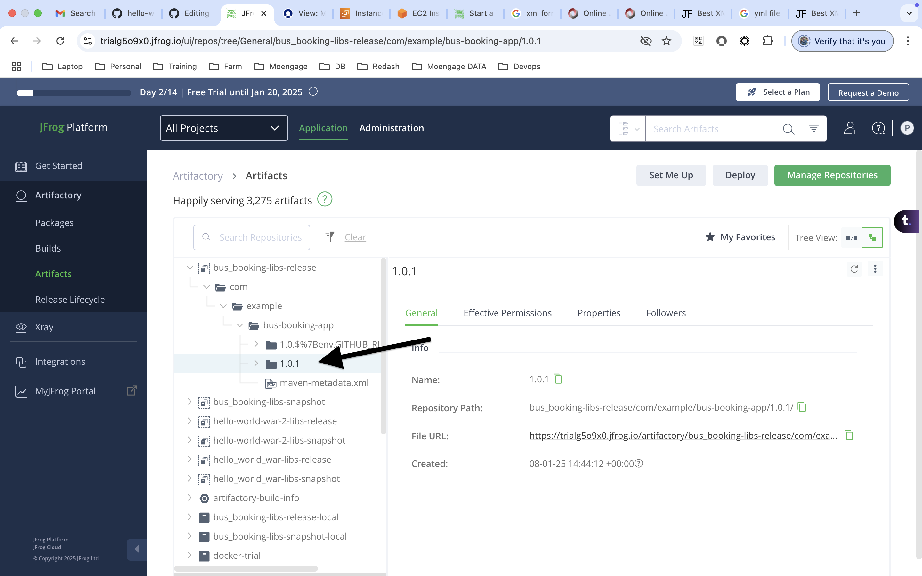

1. We will be doing the deploy using git actions now
2. Update the pom.xml under the remote repo (7-10 steps)  
   Either can we update locally and push it to remote or we can do it on the UI of the Git
3. The next step would be setting up the settings.xml. Here we are trying to deploy the artifact using git actions, so there won’t be setting.xml here. Instead, we use maven.yml file
4. git actions will try to run the deploy on it’s own instance, so git actions will create a maven.yml file under the .m2 folder of that instance
5. Here instead of providing the username and password in a file, we will be storing it in a variable
6. Select actions under secrets and variables  
   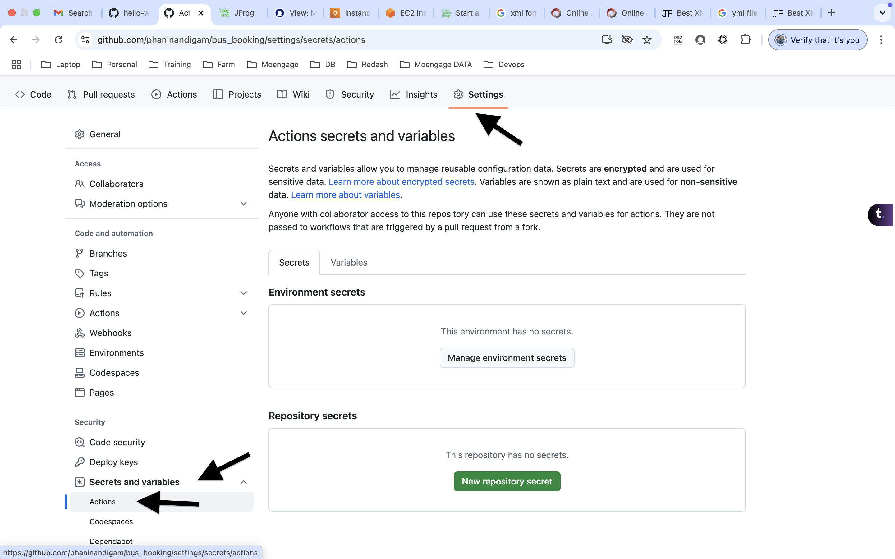
7. click on new repository secret  
   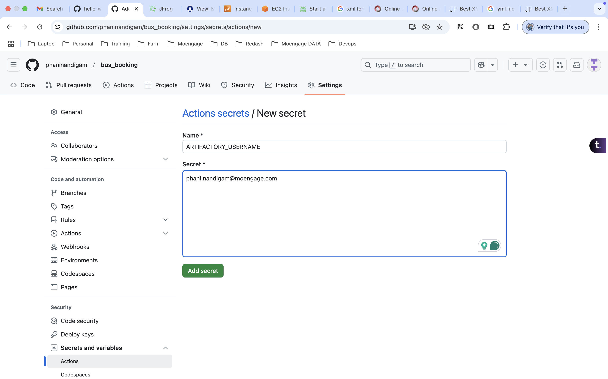  
     
   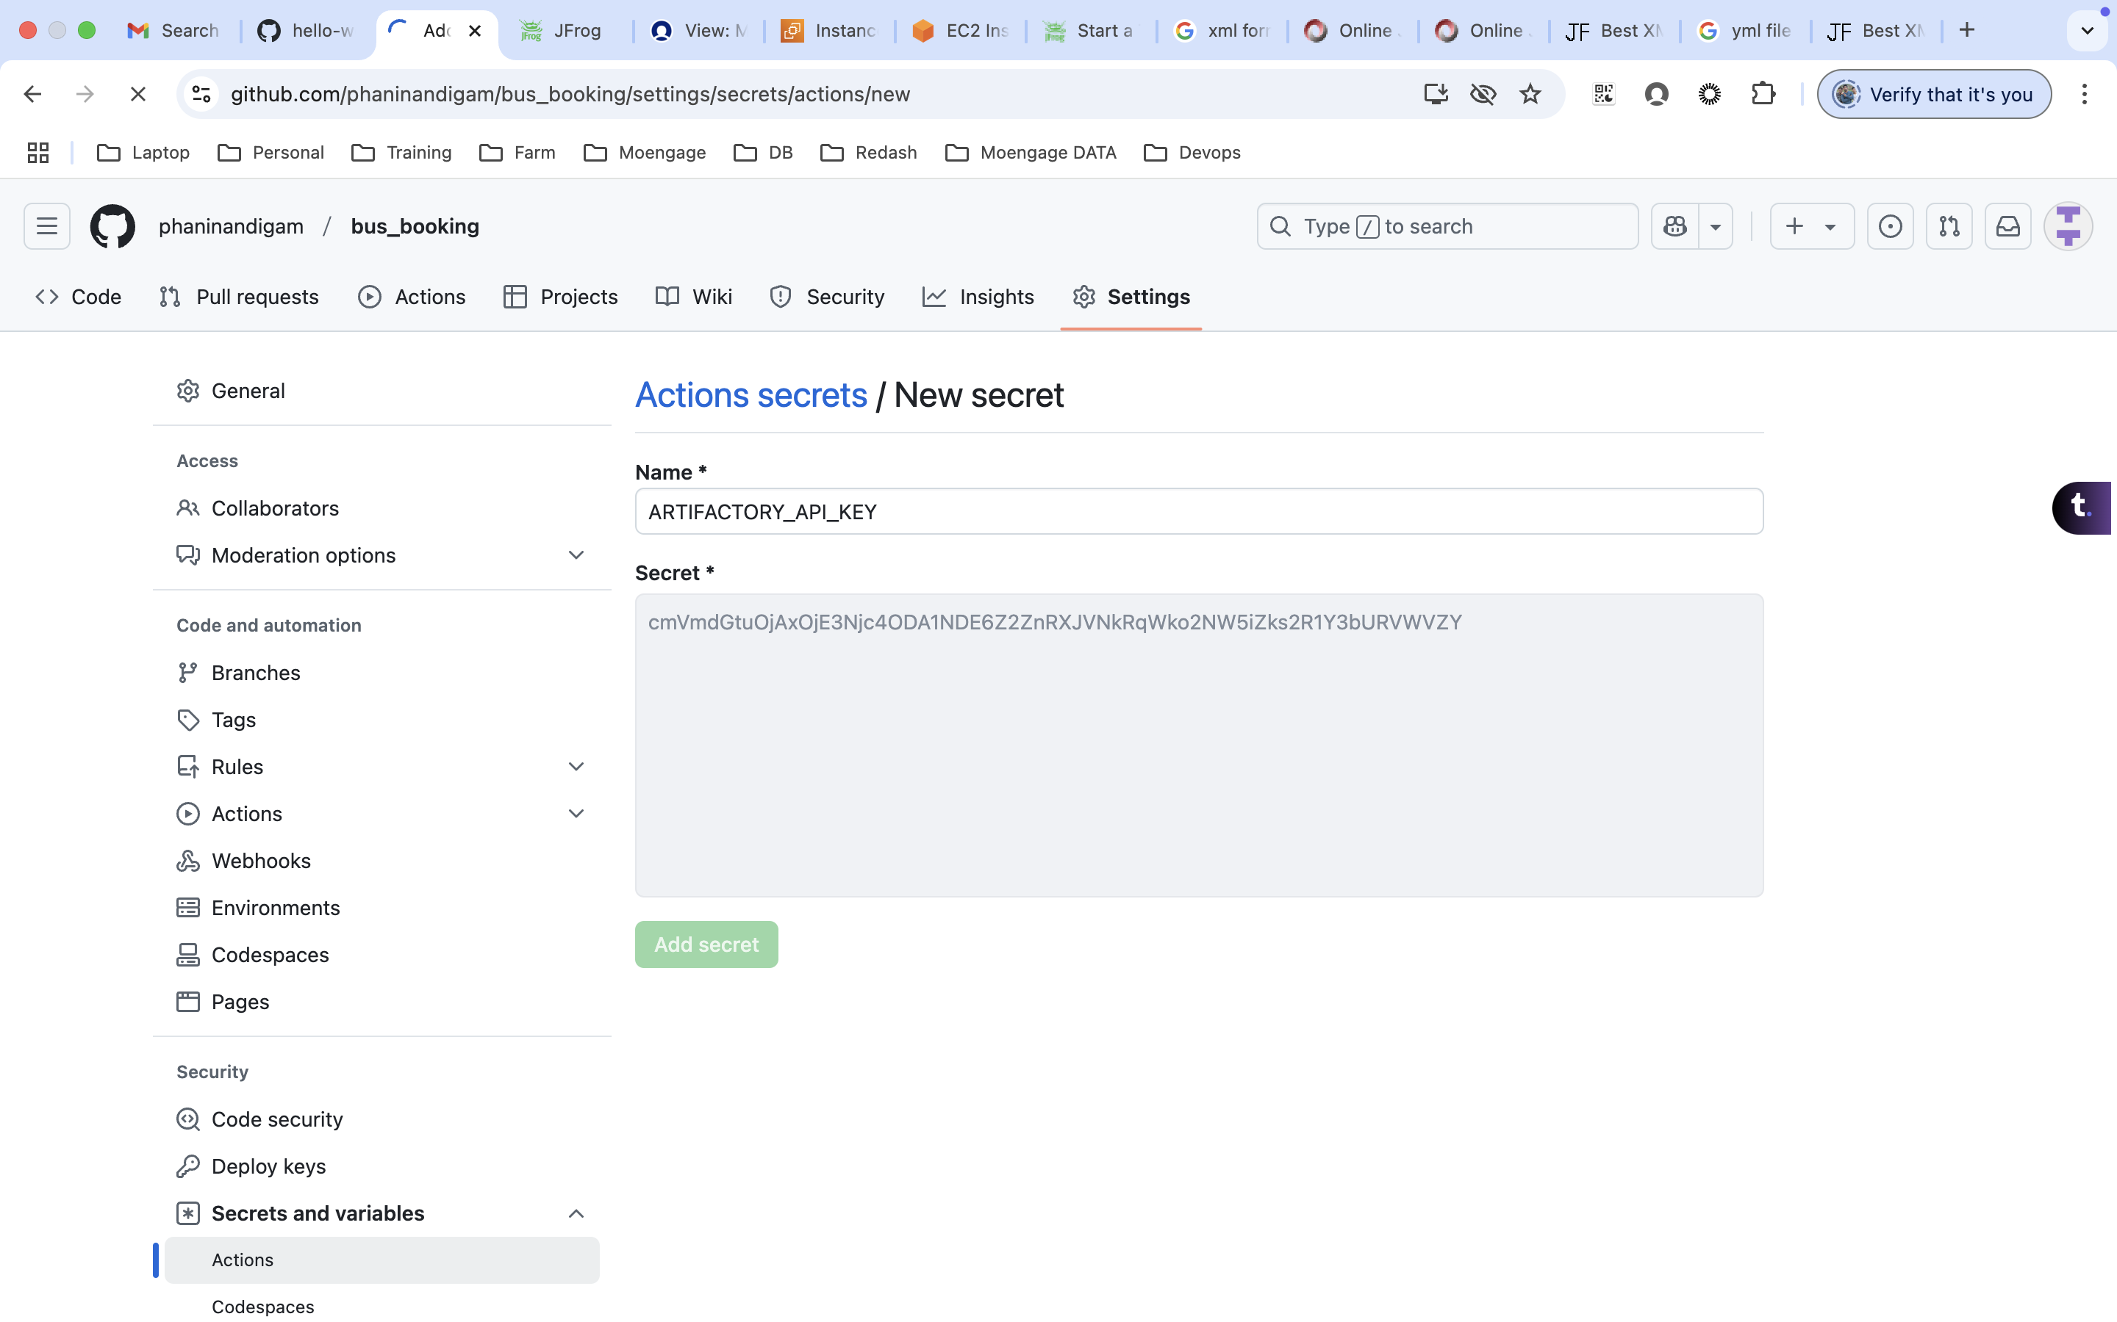  
     
   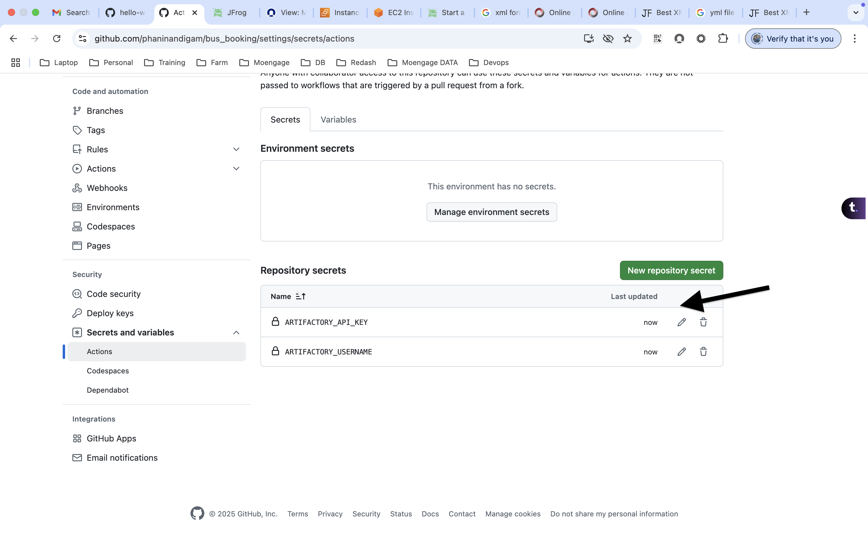
8. click on Actions and search for ‘java with maven’ and click on configure  
   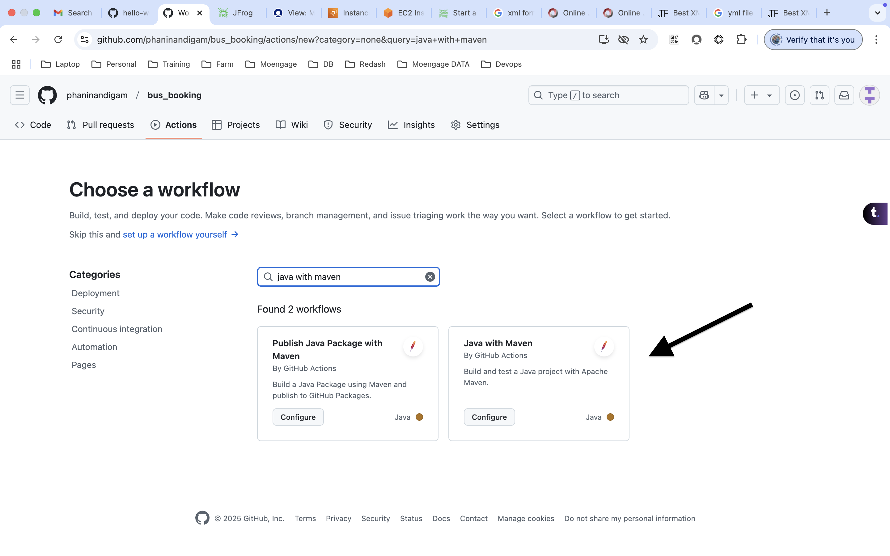
9. Add the below content on maven.yml file, add it after the ‘cache: maven’ line

|  |
| --- |
| - name: Configure Maven settings  run: |  mkdir -p ~/.m2  echo "<settings>  <servers>  <server>  <id>central</id>  <username>${{ secrets.ARTIFACTORY_USERNAME }}</username>  <password>${{ secrets.ARTIFACTORY_API_KEY }}</password>  </server>  </servers>  </settings>" > ~/.m2/settings.xml |

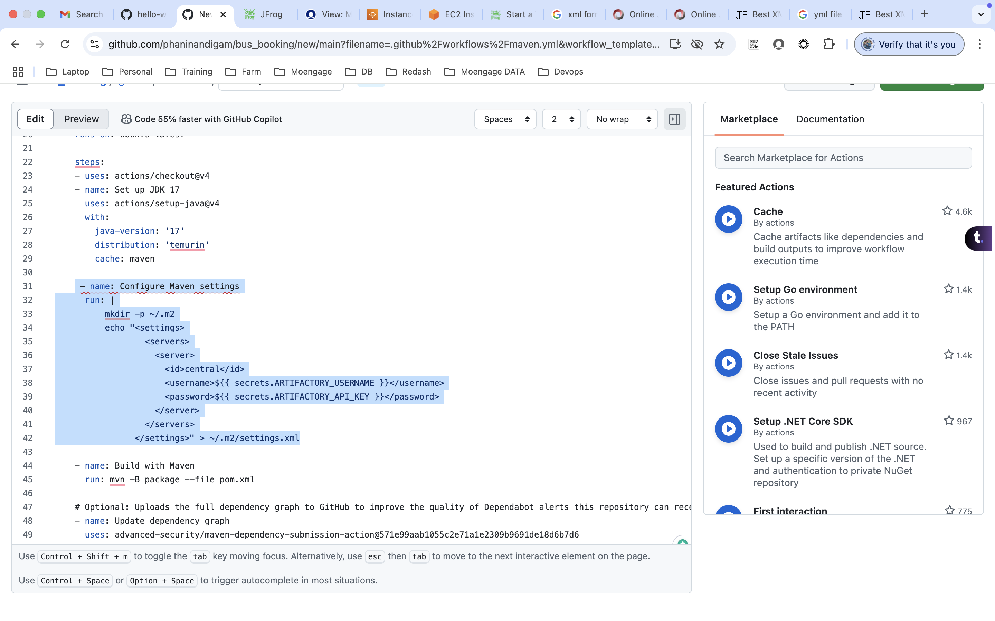

1. Click on commit changes and it will try to build automatically and you can view it under actions.  
   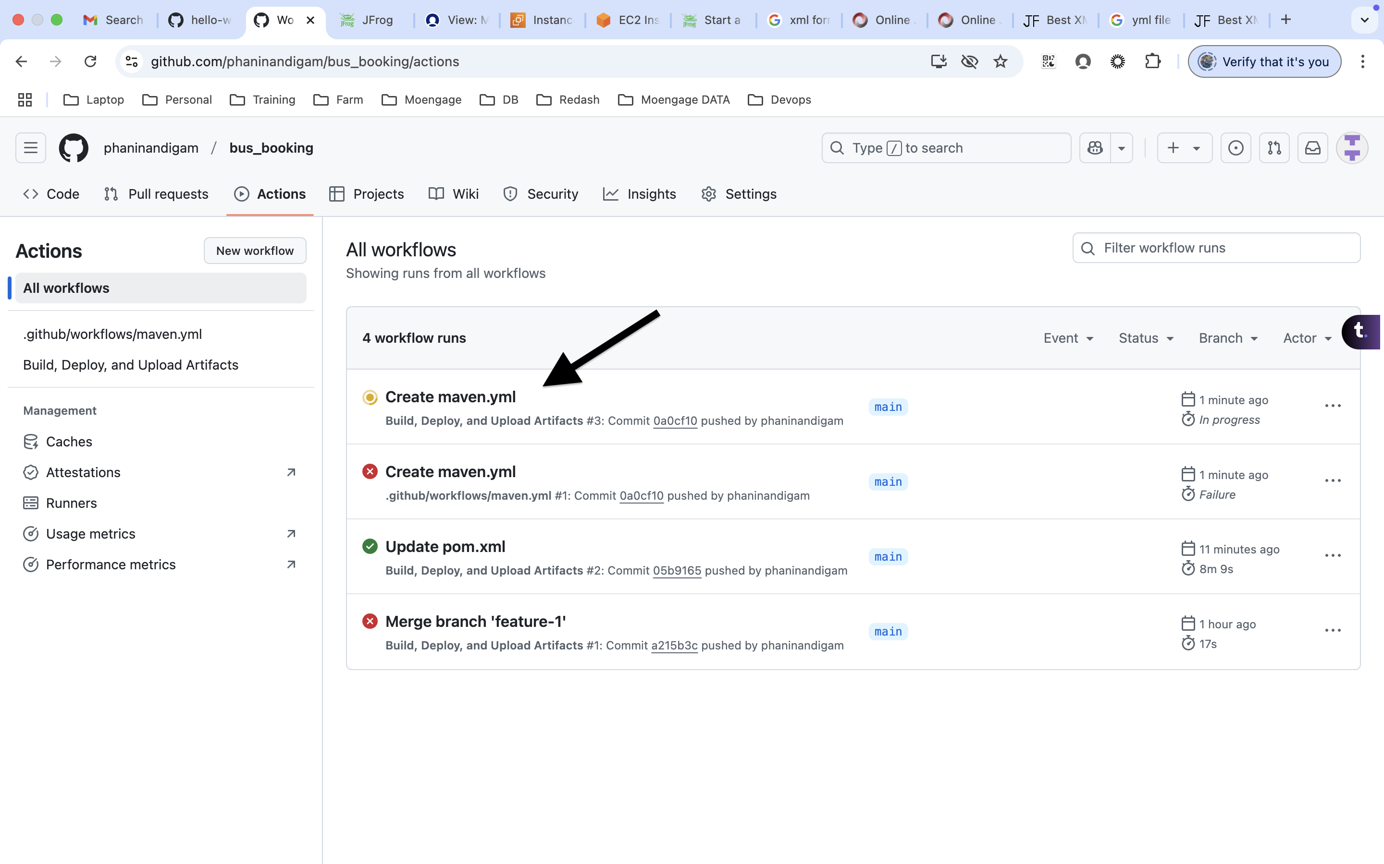  
     
   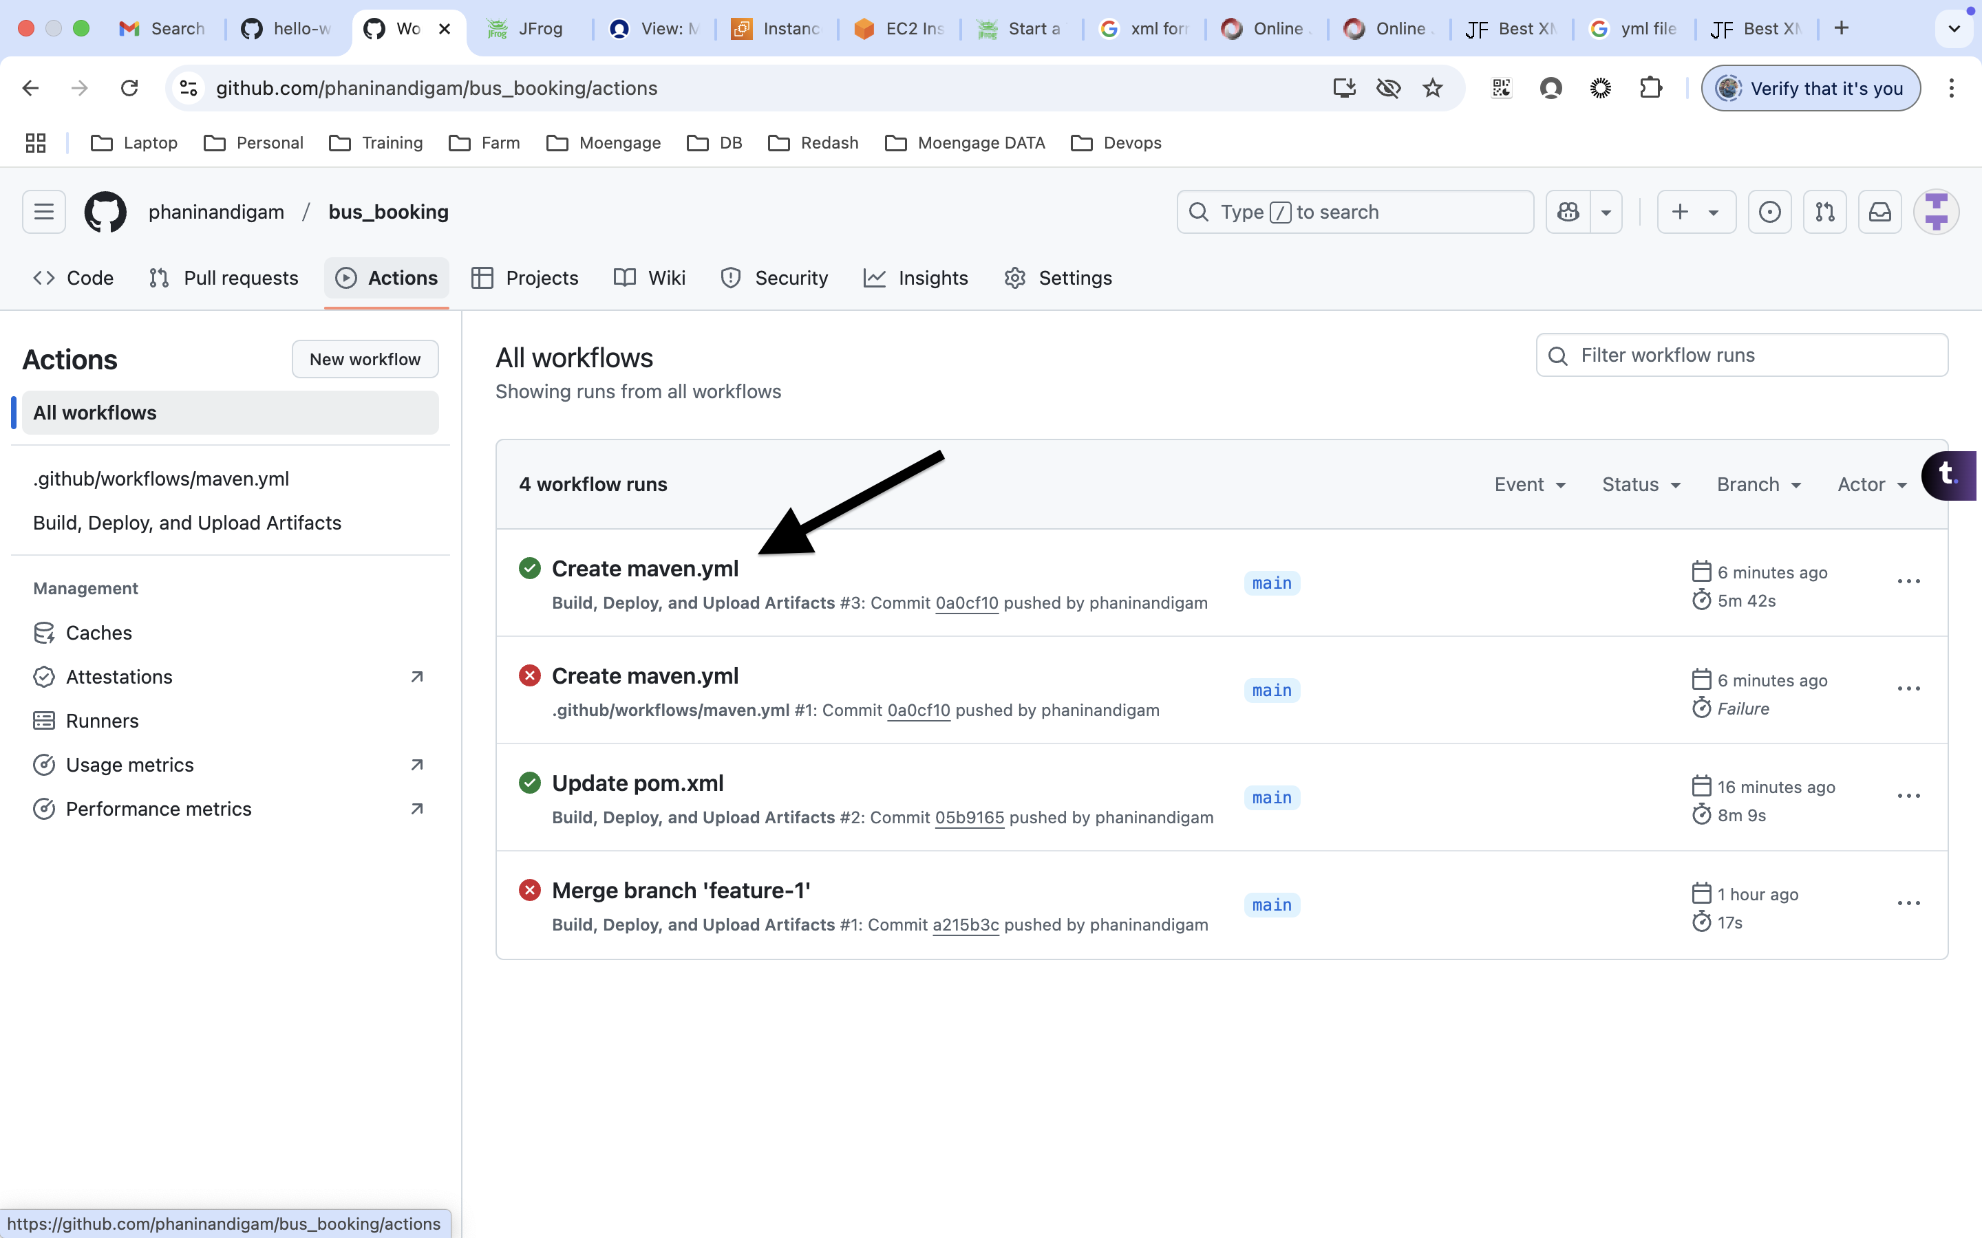
2. If there any error we need to fix it.
3. Now every time we commit changes to this repo, it will be build and deploy the artifact to the Jfrog.

**Note:** Using the below code to update the build number automatically according to the build under pom.xml  
<version>1.0.${env.GITHUB_RUN_NUMBER}</version>